CHE517 ADVANCED PROCESS CONTROL
FINAL EXAM
Professor Shi-Shang Jang Jan. 10, 2008

Problem #1 (20%)

Consider the following Internal Model Control Structure (or Model Predictive Control Structure:
G_{I}
G_{m}
G_{P}
y_{s}
e
d
y
y_{m}
u
+
+
+
-
-
+

Show that:

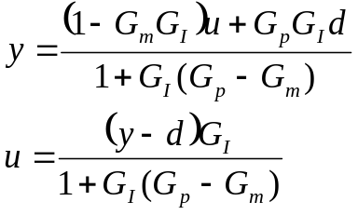

Based on the above derivation, also show that:
- Dual stability: y and u are both stable provided that G_{p}=G_{m}, G_{p} and G_{I} are stable.
- Perfect Control: y=y_{s} provided that G_{p}=G_{m}, G_{p}=G_{I}⁻¹ and G_{I} realizable.
- Zero offset: y(0)=y_{s}(0) provided that G_{m}(0)=G_{I}⁻¹(0).

Problem #2 (20%)

The mixing tank in the following figure has two independent inlet streams of pure A and B that can be manipulated. The outlet flow cannot be manipulated by the unit; it has to be a unit of higher priority. The composition, the weight percent of B, and the level are to be controlled.
- Derive a linearized model of the system.
- Determine whether the system is controllable.
- Calculate the relative gain array for this process and make conclusions about the possible loop paring for this system.
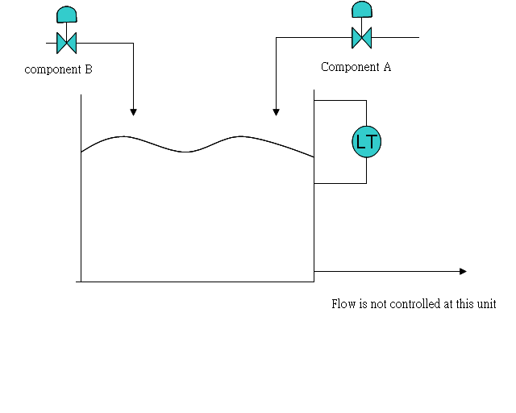
AT
%A
Problem #3 (20%)
Derive a pulse transfer function (z-domain) for the following plants with a zero order hold and a sampling time of 1:
- 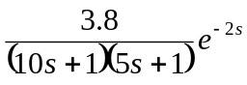 (6 points)
- 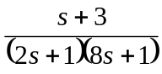 (6 points)
- 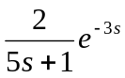 (7 points)

Problem #4 (20%)
A cascade control configuration is sometimes used to separate different objectives of feedback control. For instance, first an inner loop can be used to stabilize the process, and then an outer loop can be used to control the output to track set-point changes and reject disturbances. An example of a cascade control system is shown in the following figure. The process transfer function
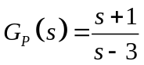
is unstable.
- Determine the maximum range of Kc₂ values for which the inner loop will be stable.
- Now assume Kc₂=6 and Gc₁ is a PI controller with gain Kc₁ and τ_{I}. Find the values of Kc₁ and τ_{I} such that the closed-loop poles of the transfer function from Y_{sp} to Y(s) are at s=-0.5±0.2j.

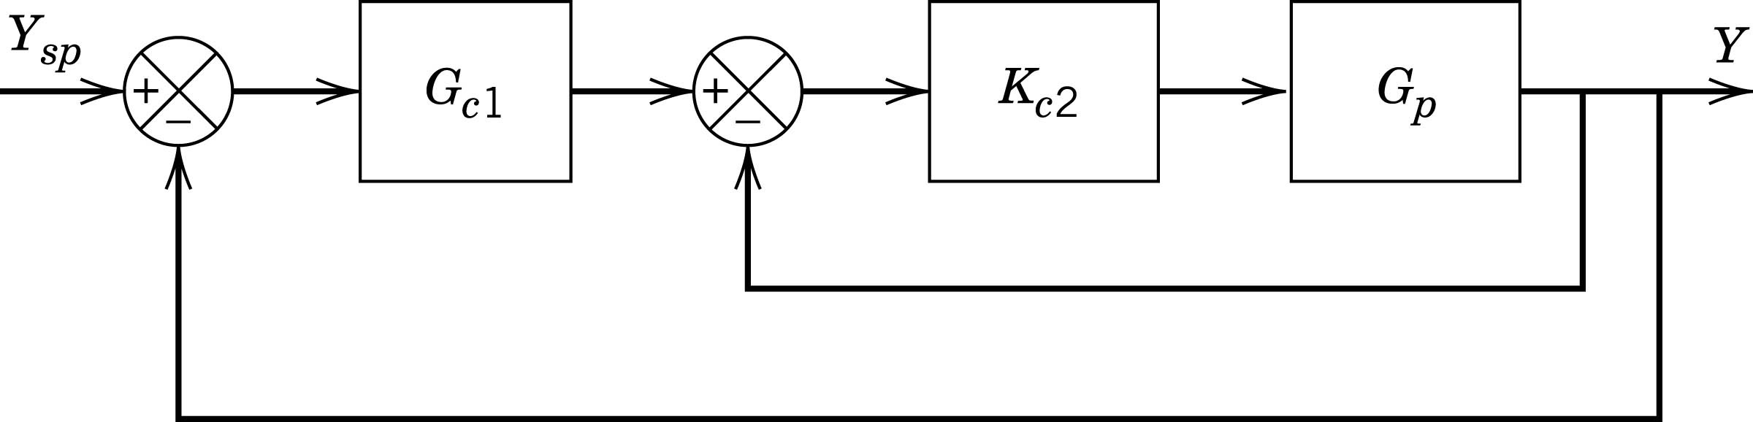

Problem #5 (20%)
The outlet temperature of the process fluid and the oxygen in the flue gas can be controlled in the fired heater by adjusting the fuel pressure (flow) and the stack damper % open. A dynamic model for the fired heater was reported and is repeated here:
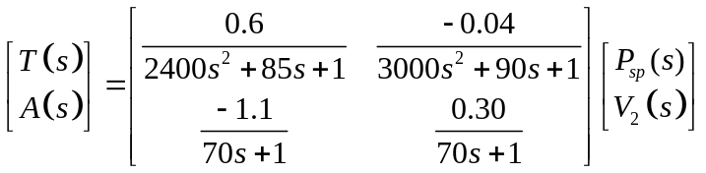
The inputs and outputs are in percent of the range of each instrument, and the time is in sec.
- Determine whether the input-output combination is controllable.
- Determine whether either loop pairing can be eliminated based on the sigh of the relative gains.

